Project Overview:
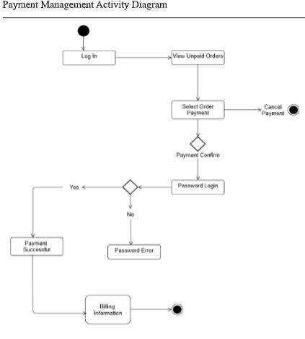
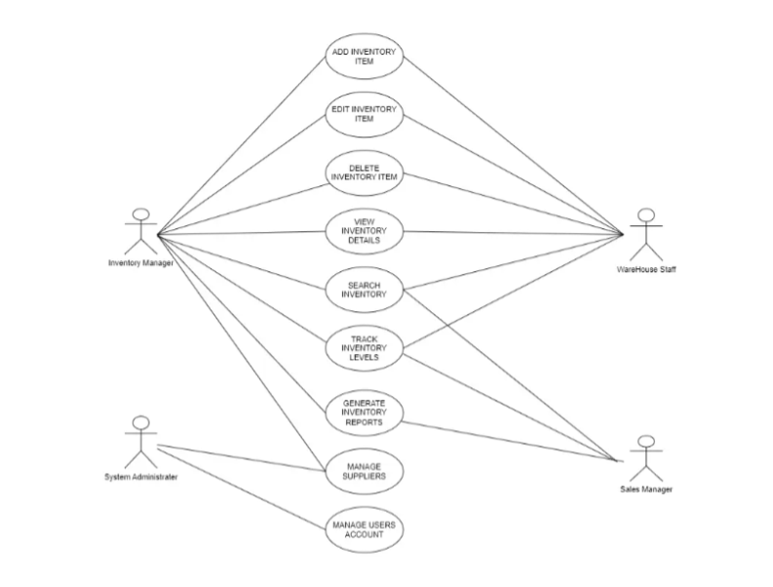
Class Diagram:
Problem Statement:
Inventory Management System:
Manual inventory management leads to poor stock tracking, order
delays, and payment errors. This system automates stock ordering,
supply, payment, and product tracking between an Owner and Supplier
for accurate and efficient inventory control.

Classes Identified:
Computerized Warehouse Management System
This is the main class of the system. It manages the menu and provides different
warehouse management services. It also allows the user to select the required
option.
Suppliers and Customers Database
This class stores information about suppliers and customers. The Maintenance()
function is used to maintain and update their records.
Warehouse Security
This class is used for system security. It handles login and logout and provides
functions for verifying users and resetting login details.
Suppliers and Customers Database
This class manages warehouse information such as stock, schedules and

summaries. It provides functions for managing stock, schedules and generating
summaries.
Relations
This class contains information about the item type and volume. The Type() and
Volume() functions are used to access or manage these details.
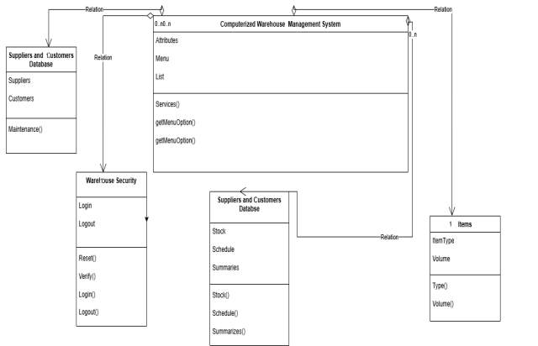
Sequence Diagram: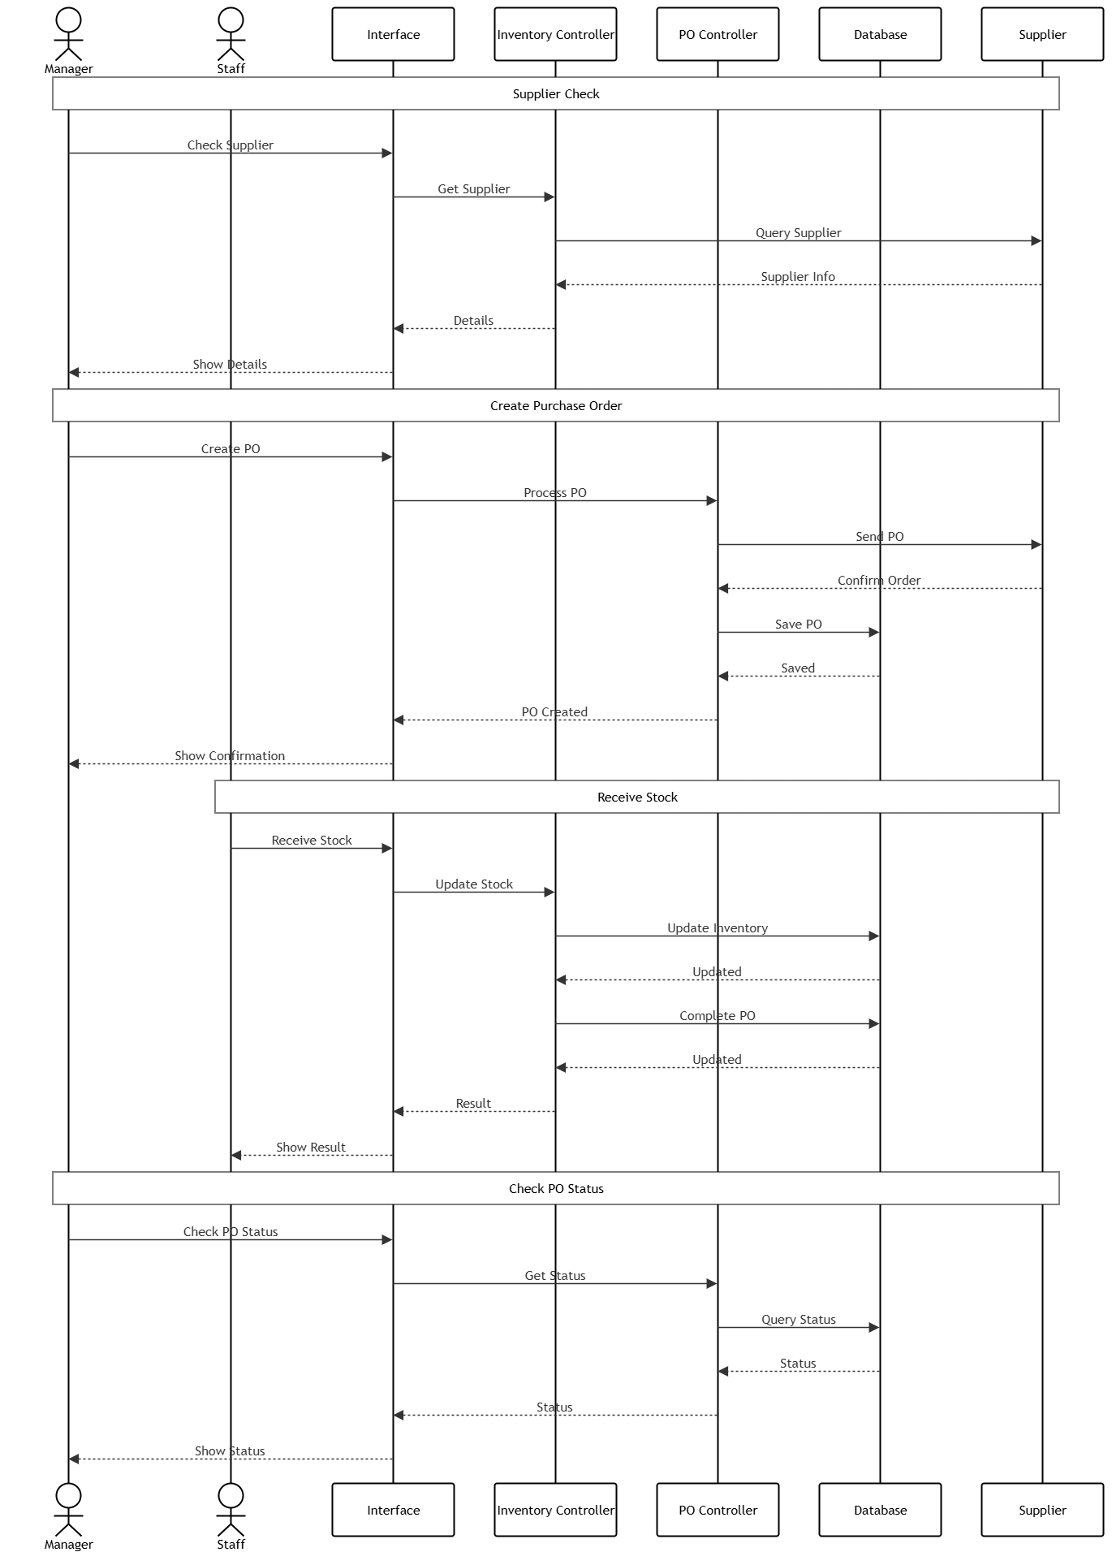

(State, Component & Deployment Diagram) Submission:
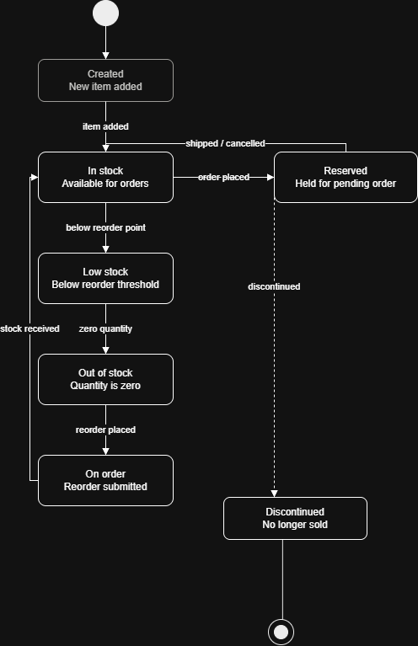
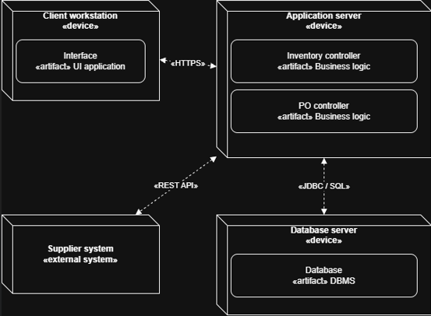
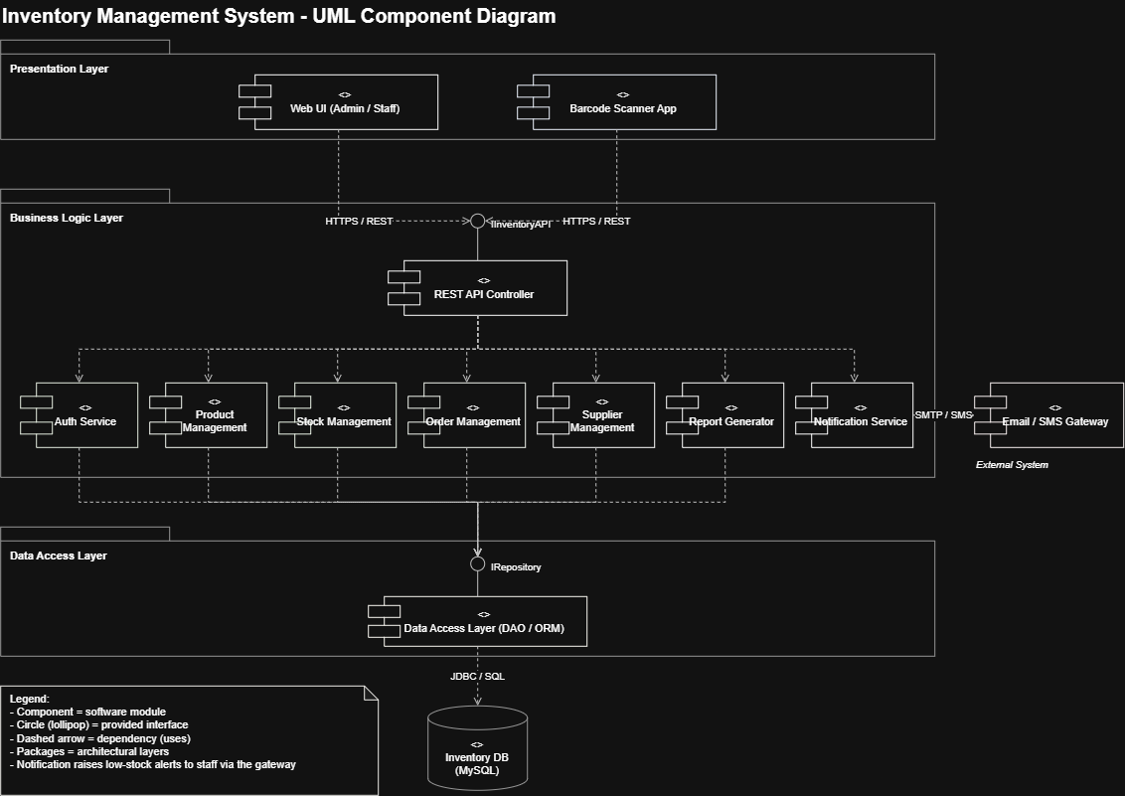
Gantt Chart:
